Project overview

Stocks are traded 24/5 with 8/5 hours and 2800 companies listed on NYSE and 3100 listed on NASDAQ.

Forex are traded 24/7 and only a dozen and 8 major pairs.

In addition, a survey of foreign exchange and OTC derivatives markets in 2016 states that there is averaged 5.1 trillion per day in April 2016 in forex.

George Soros

I found myself always fascinated

Forex can be trade in local and global minima and maxima. Whereas, stocks(equity) are buy low sell high in general practices. Therefore, there would be more signals and AI aspect on having the model train itself to trade on both ways and find the signal whether or not when to buy or sell then stock does. Also in general there is a shorter holding period on forex trading.

Forex are traded in price interest point (PIP), the measurement of changing in exchange rate pairs. With a single pip points up or down whatever the agent bets, the difference would be made or account realized.

In this case, I believe using Q learning or recurrent reinforcement learning to train different agents on different practice with back propagation. Having multiple agents would have interacted with each other whereas single one agent would not be able to determine the other agents. In addition, I would also use random trading test to see whether or not how is the performance like.

There have been different research studies on forecasting foreign currencies trading with neural networks. The earliest I found was received in 1997 and the latest well quoted one was in 2009 from cs229 Stanford machine learning final project.

With the reinforcement learning from last self-driving cab project, I really want to take this further and tackle real world problem. Therefore, I combine what my passion during my undergrad from my currencies class taught by Matt Dlooney and built this

Also I am referencing majority of the studies from various research that has been done in this field , and majority of it from the

Forex can be trade bear or bullish. Therefore, this can be more complexity than stock.

Draft

One of the lastest paper by Imperial College London by James Cumming suggested in 2015 :

Least-Square Temporal Difference learning is suggested due to the long and short hold and argues that gradient descent

“TD(λ) policy evaluation methods that use function approximation aim to converge to a vector β such that V π(s) = β φ(s) where π is the fixed policy to be valued, s is a state and φ(s) is a feature vector used to represent s as a numerical vector. The traditional TD(λ) method requires the choice of stepsize parameters which it then uses to update β in a form of stochastic gradient descent. Unfortunately, incorrect choices of these stepsize parameters can often lead to poor results and the stochastic gradient descent nature of the algorithm means that it often uses the available data inefficiently [23]. Least-Squares Temporal Difference (LSTD) learning is a temporal difference technique first proposed by Bradtke and Barto [25] that aims to resolve these issues. Rather than using gradient descent, LSTD iteratively builds an explicit matrix A and vector b such that β can be estimated as β = A−1b.

Note. When computing A−1b, it may happen that A is singular and traditional matrix inversion will fail. It is therefore recommended that one uses the Moore-Penrose Psuedoin- verse and Singular Value Decomposition to compute the best fit solution [26].

”

Yahoo Finance API seconds data

*Technically*

*Trends of average daily performance, any cycles, as well as is there any finding from the 7 years of data.*

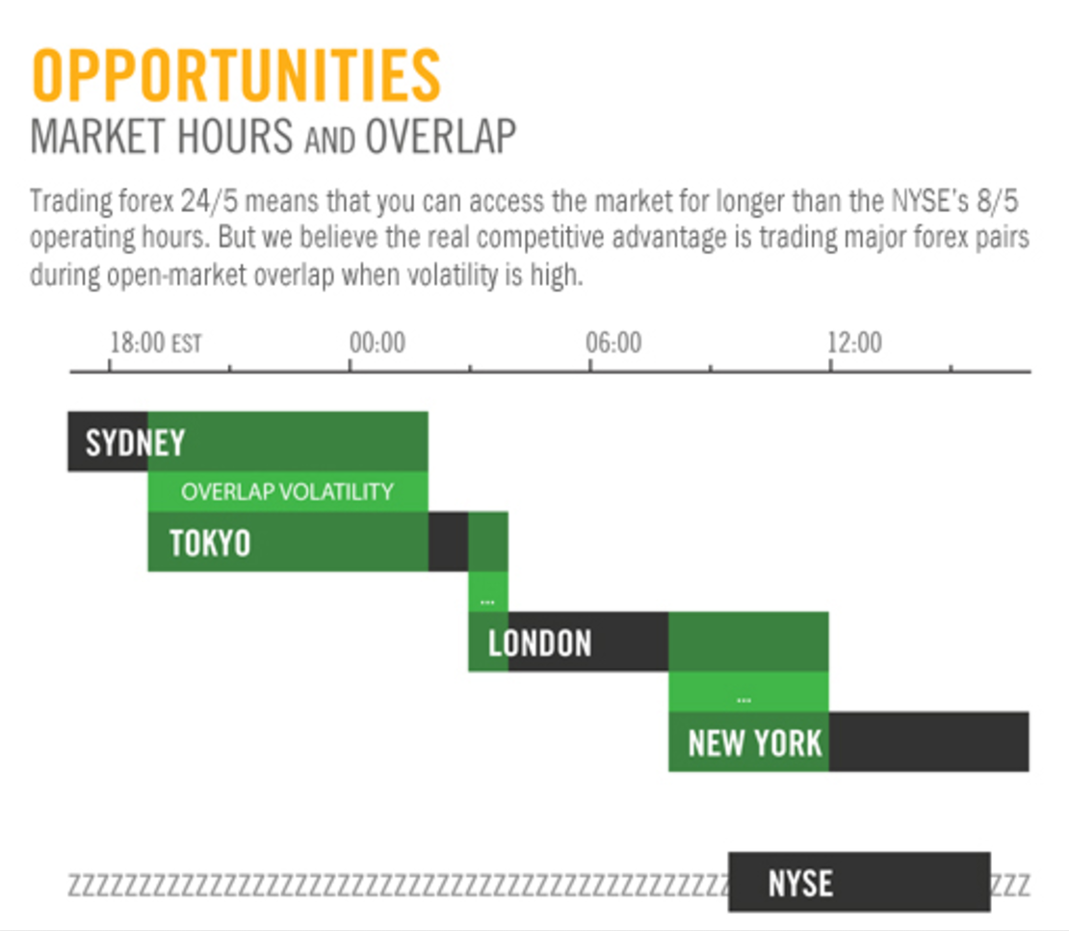

**Problem statement**

**Metrics**

Total return on portfolio will be the major metric to test the success of the AI. Also comparing to the top forex traders named by Forbes magazines in 2015

Ref:

<http://www.bis.org/statistics/full_data_sets.htm>

<https://www.cs.toronto.edu/~vmnih/docs/dqn.pdf>

<http://hallvardnydal.github.io/new_posts/2015-07-21-deep_q/>